Today’s Fit by Sandra Betzina
General fabric size requirements are listed to give you an idea of what you will need.
Go to WWW.POWERSEWING.COM to see Sandra’s latest fashions.
*Pattern illustrations are below their assigned pattern numbers

Vogue 1820 A 45”, 60”– ¾ -1 ½ B 60”- 2 ¼ C, D 60”– 3 ¾ Vogue 1843 A 60”– 3 B 60”- 2
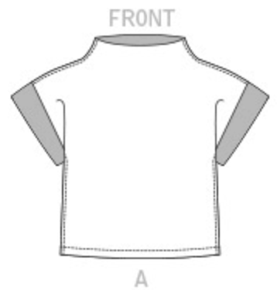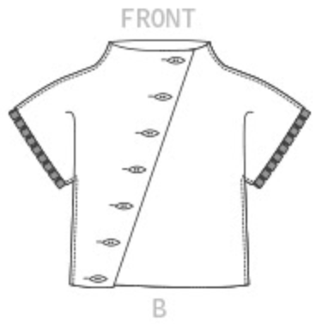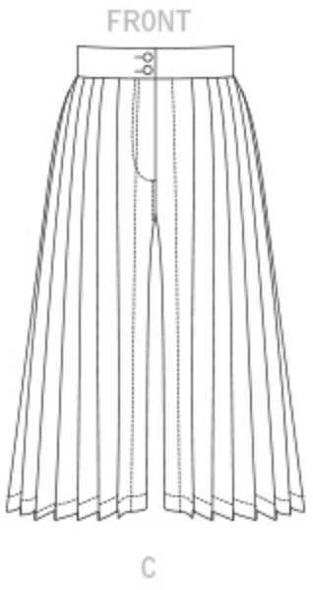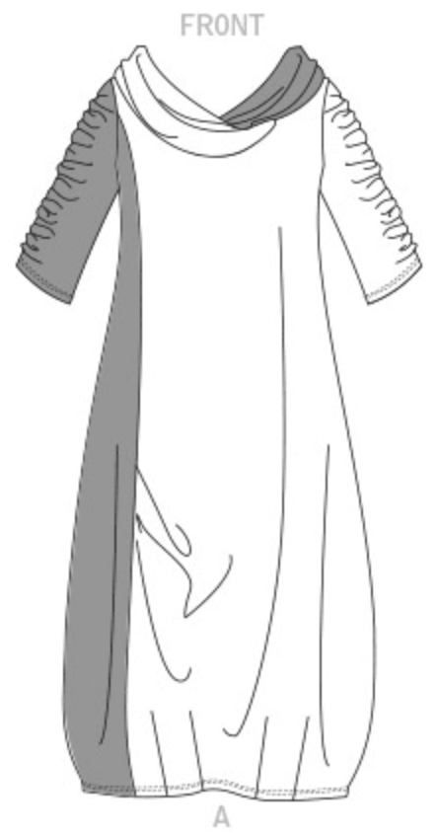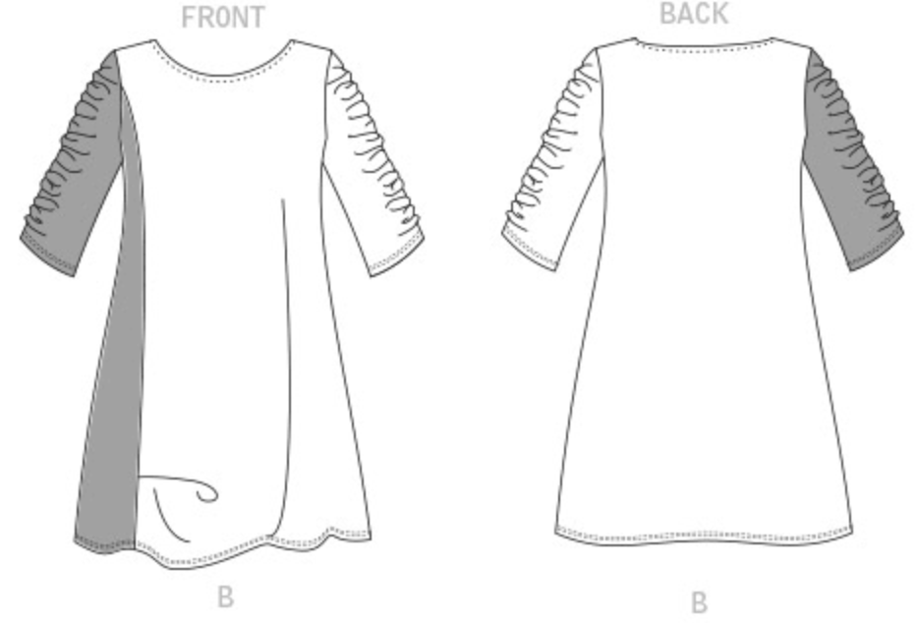

Vogue 1820 A 60”– ¾ -2 ½ B 60”- 1-2 C 60”– 3 1/8
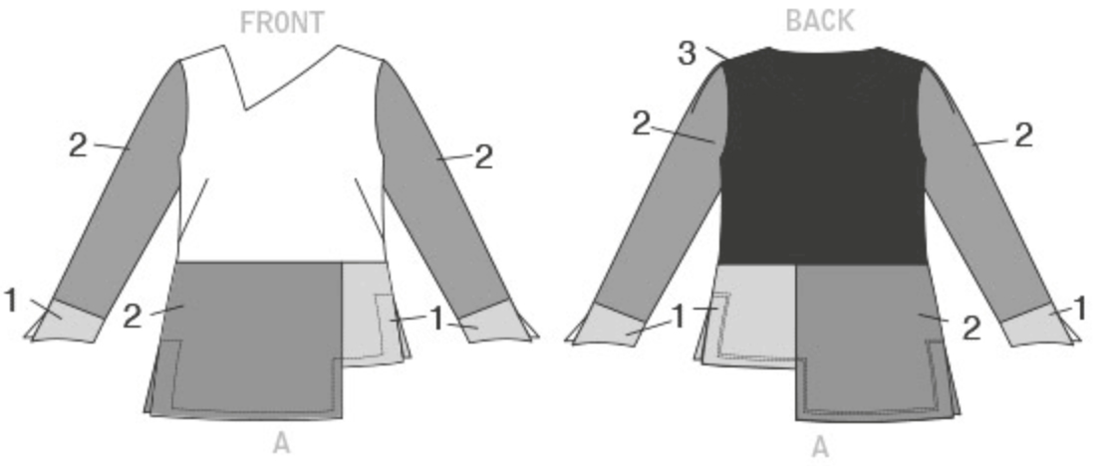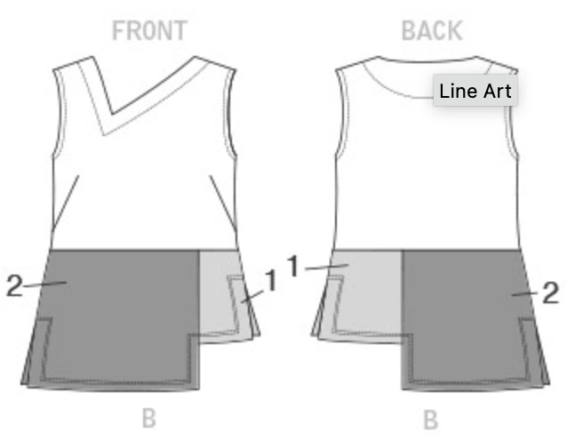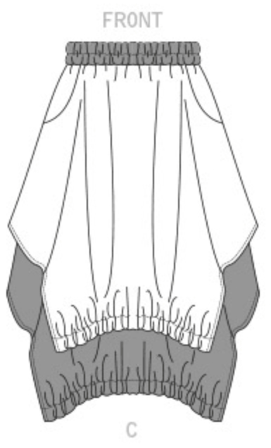

Vogue 1805 A 60”– 2 ½ B 60”- 1 ¾ Vogue 1792 A 45” – 4 ½ , 60”– 3 ¼
C 60”– 2 1/8 D 60”– 2 1/8 B 45” – 5 , 60”– 4

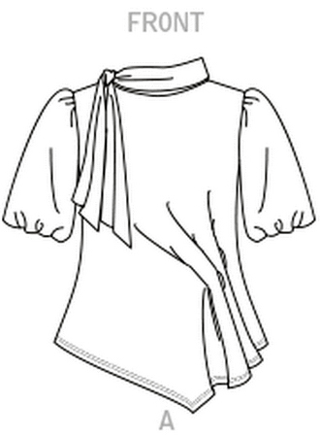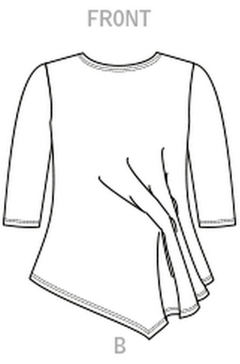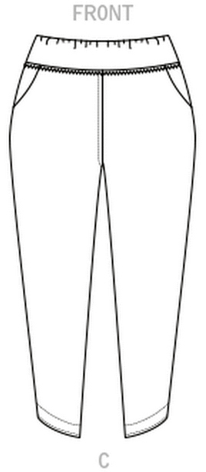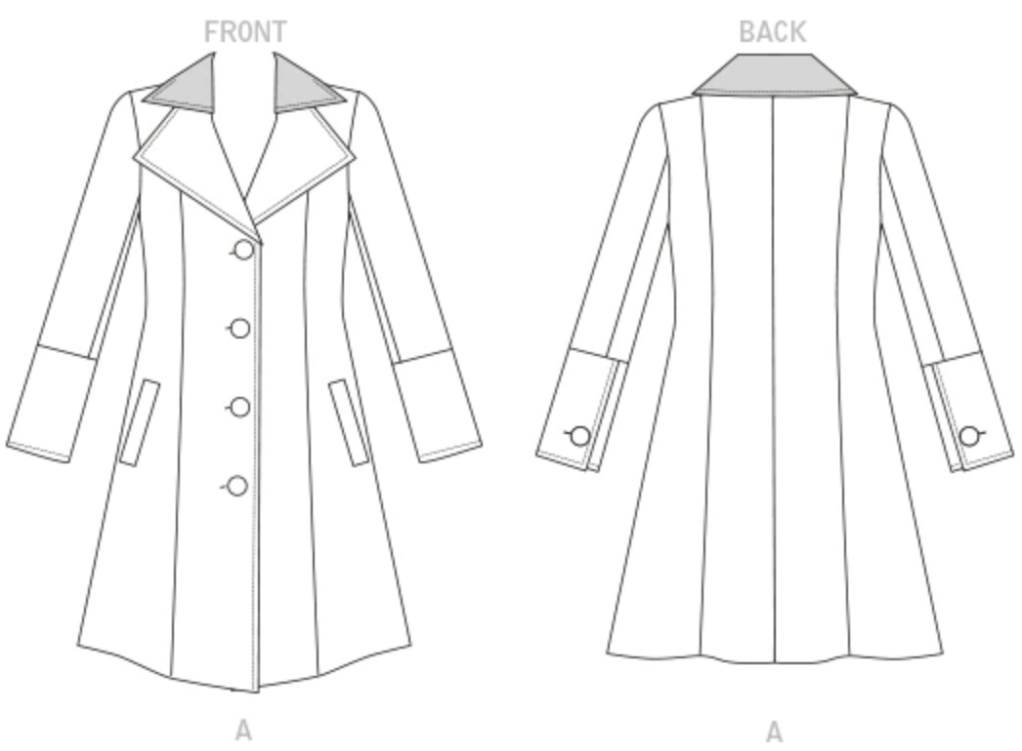

Vogue 1715 A 45” – 2 ¾ , 60”– 1 7/8
Vogue 1756 A, B 60”– 4 ¼ B 45” – 3 ½ , 60”– 2 5/8
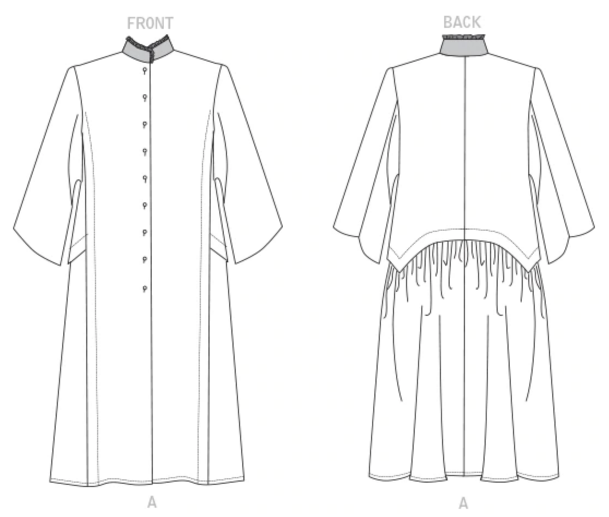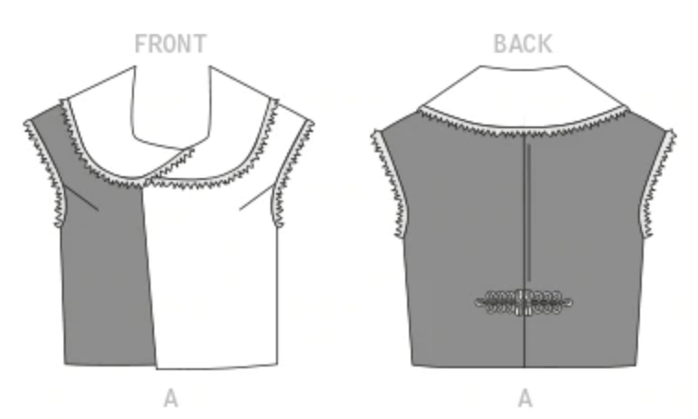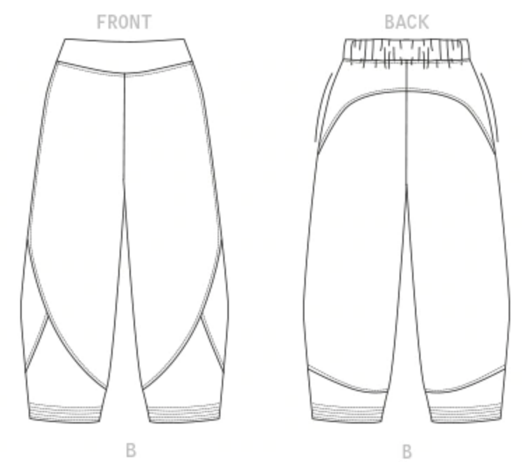

Vogue 1713 A 45” – 2 ¾ , 60”– 2 Vogue 1705 A 60”– 1 ½ B 60”- 1 ¾
B 45” – 4 , 60”– 2 ¾ C 60”– 4 ½ D 60”– 4
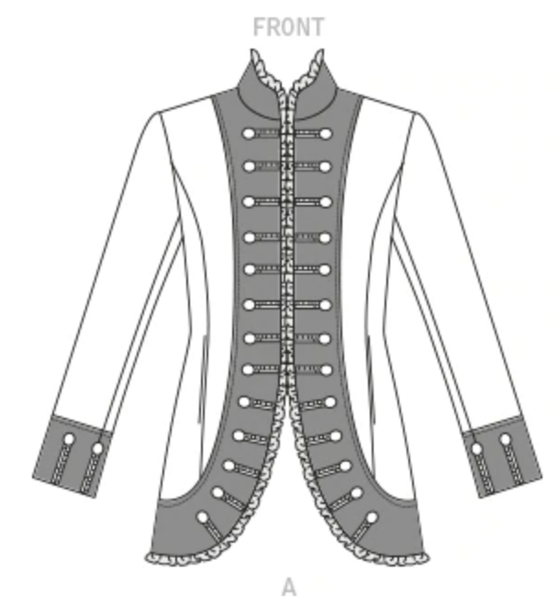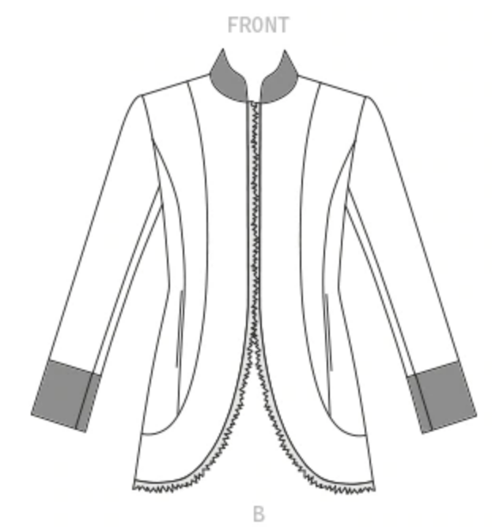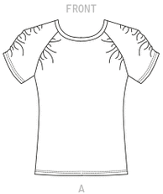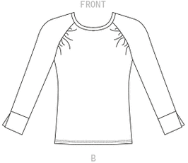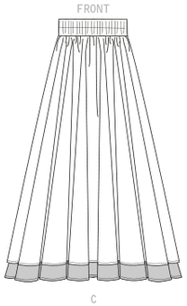

Vogue 1695 A 45” – 4 ¼ , 60”– 3 ½ Vogue 1690 A 45” – 2 ½ , 60”– 2
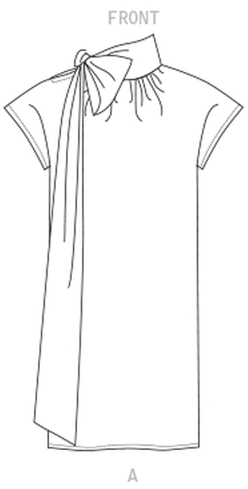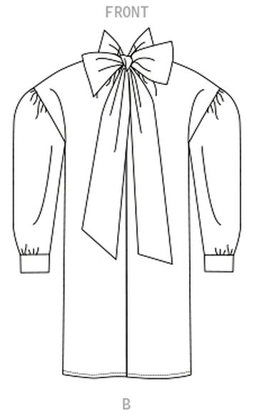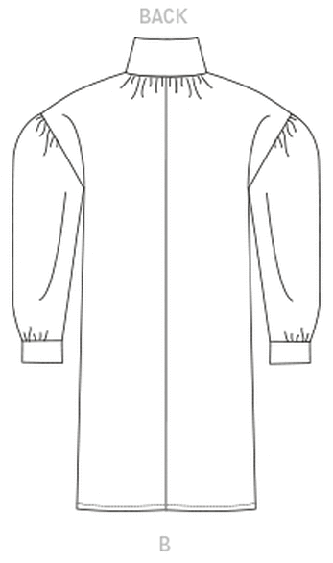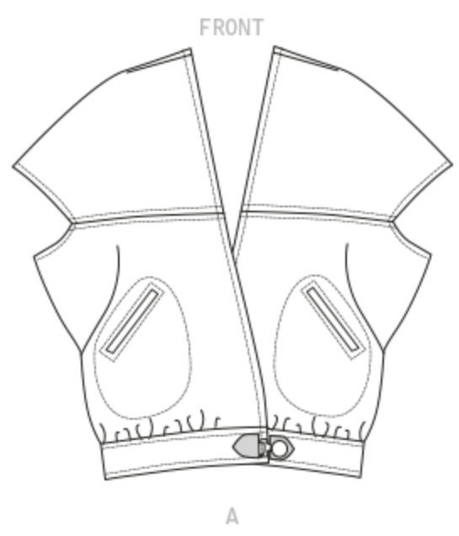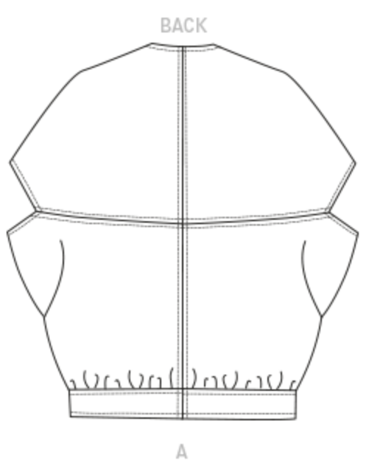

Vogue 1682 A 45” – 2 7/8, 60”– 2 1/8 Vogue 1664 A 60”–3 ¼ Vogue 1662 A 45”- 3 7/8, 60”–3
B 45” – 3 3/8, 60”–2 3/8 B 60”–2 ¾
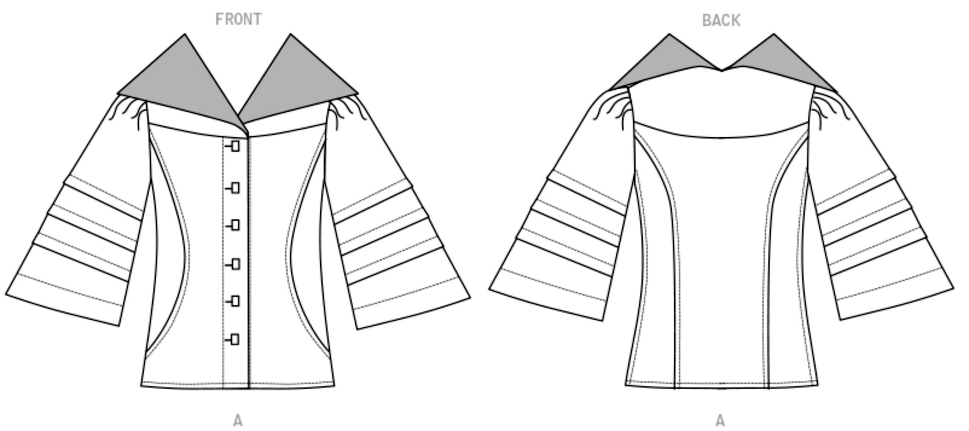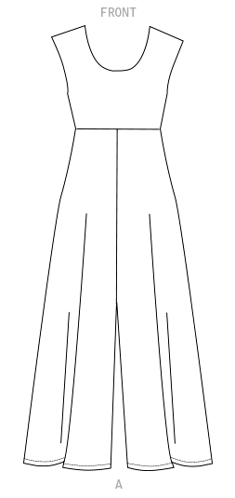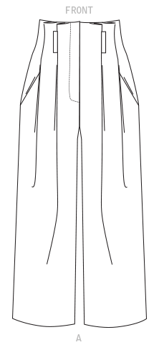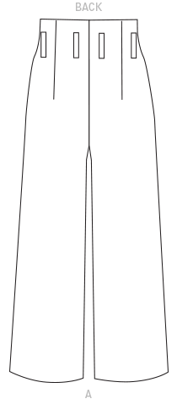

Vogue 1630 A 45”-2, 60”–1 1/8 Vogue 1610 A 45”, 60”– 3 ¼, B 45” – 4, 60” – 3 ¼
B 60”– 1 ¾ , C 60”– 2 C 45”, 60”– 3/8 D 45”, 60”– 3/8
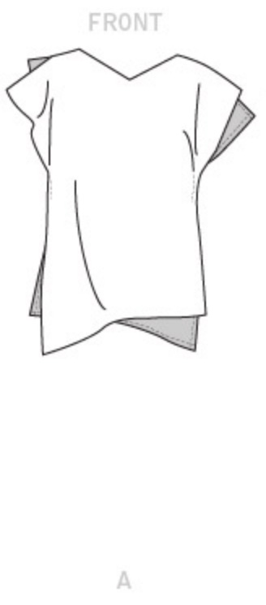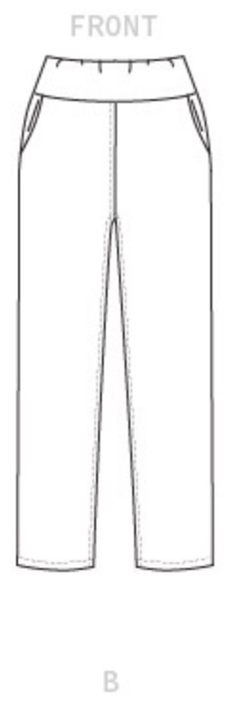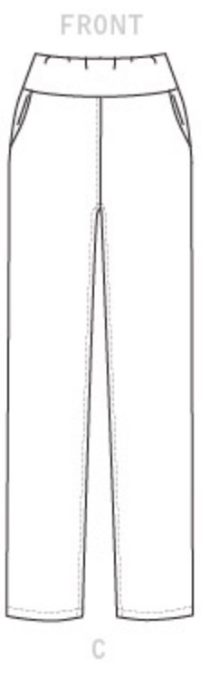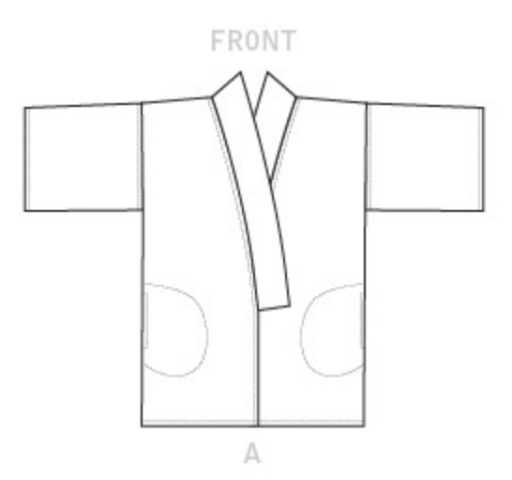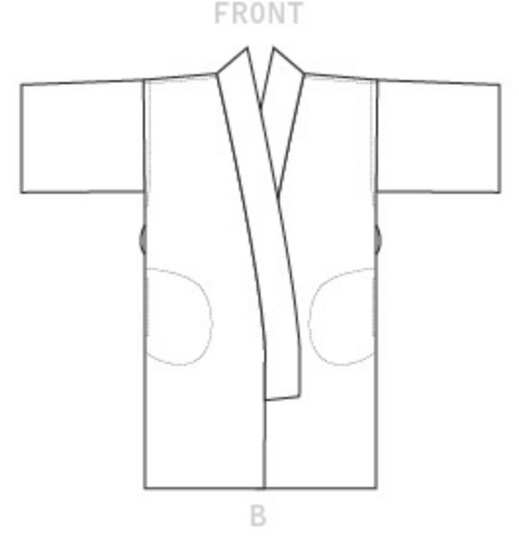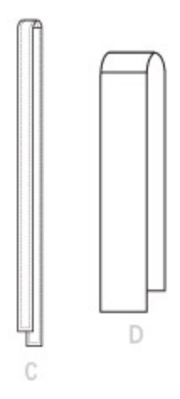

Vogue 1583 A 45”,60”– 2 B 45”– 2 ½, 60”– 2 Vogue 1456 A 45”- 3 ½, 60” – 2 ¾ Vogue 1234
C 45”, 60”– 1 ½ D 45”– 1 ½, 60”– 1 ¼ B 45” – 2 7/8, 60” – 2 ¼ A 60”– 3 ½
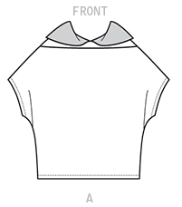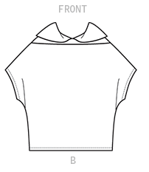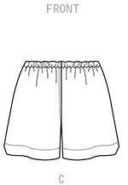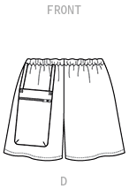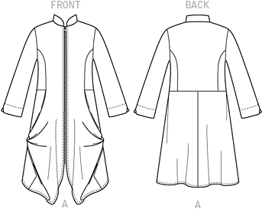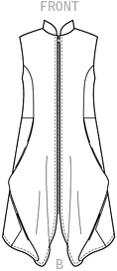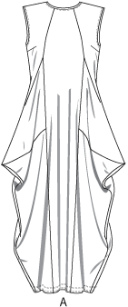

Today’s Fit Sizing in Vogue (inches)
Size | A | B | C | D | E | F | G | H | I | J
Bust | 32 | 34 | 36 | 38 | 40.5 | 43 | 46 | 49 | 52 | 55
Waist | 26.5 | 28.5 | 30.5 | 32.5 | 35 | 37.5 | 41.5 | 44.5 | 47.5 | 50.5
Hip | 34.5 | 36.5 | 38.5 | 40.5 | 42.5 | 45 | 48.5 | 51 | 54 | 57

